Sprint delivers to UPS (United Parcel Service)

11-27-2006

The next time that familiar brown UPS (United Parcel Service) truck rolls into your driveway, give the driver an extra smile. UPS is a longtime, loyal customer and also one of our largest accounts. UPS currently spends in excess of $100 million annually with our company.
But, this past summer, a major PBX systems issue at their Louisville, Ky., International Air Hub had to be addressed to keep this valued customer satisfied.
The UPS executives, aware of the company’s and CEO Gary Forsee’s unwavering commitment to improving the customer experience, brought the issue to the attention of Sprint leaders.
Tim Smith, director-Network Engineering pulled two of his best managers, Travis Porter, manager- Network Engineering, and Doug Musick, technical manager, off of other projects and dedicated them to the UPS contract. As the primary troubleshooters on the project, they worked seven days a week, including nights and weekends, for six weeks this summer, leaving no time for the usual family vacations.
"We started after July 4th and worked through Aug. 19. The PBX systems are sophisticated and complicated. The overall functioning also depends on software provided by our partner, Nortel networks, and power and grounding provided by UPS. It was a challenge to figure out what was wrong, but a great relief for everyone once we succeeded in stabilizing the system," Musick said.
"Initially, the project was very stressful," Porter says, of daily phone conversations with top UPS executives taking place during the project. "They didn't believe anything we told them at first but over time, they came to trust us."
Porter and Musick received help from additional Sprint and Nortel engineers to reduce a punch list of 1,000 items down to 0. This included everything from correcting issues related to power and grounding, to installing 500-600 software patches and replacing approximately 100 pieces of hardware.
Because of the always-on nature of UPS' business, most of the work had to be done at "off times"- evening and weekends in short time windows which would have minimal impact on UPS activities. This proved an extra challenge.
Fortunately, thanks to the extraordinary work of Porter, Musick and their team, Sprint reinforced the UPS account and turned the customer around. Several months later, it's clear that the PBX systems are working fine, and UPS is now a Sprint ally. In addition, Sprint is in the running for additional sales on a new air park yet to be built.

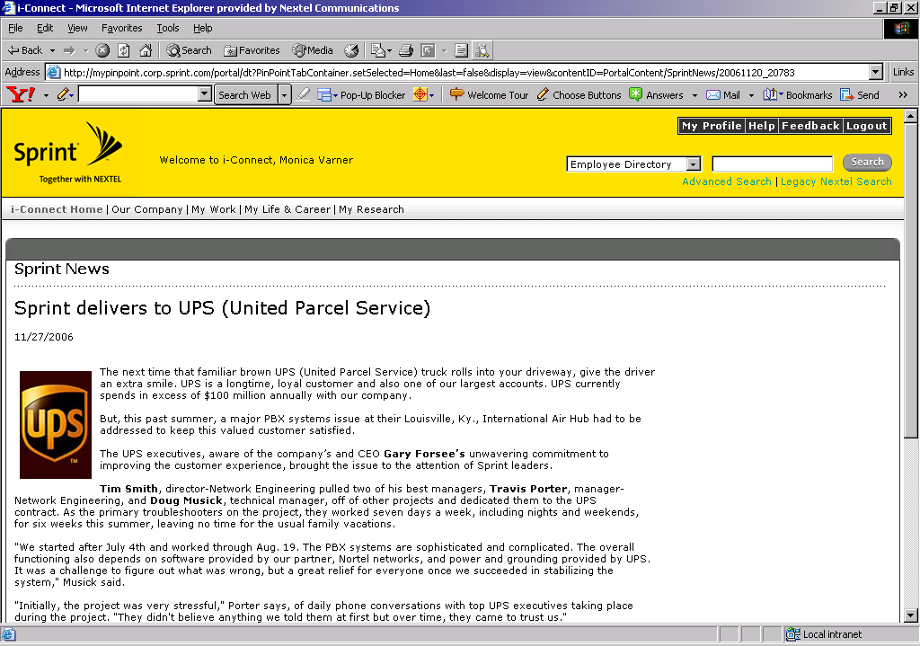

Article #2- Wild Hogs

Wild hogs, alligators, snakes ... no match for fallen hunter and cell phone

(March 2, 2006) One thing is certain, Florida resident Peter Wright never lets his i205 Nextel phone go uncharged anymore. He credits it with saving his life on a hunting trip in the Central Florida wilderness.

In rural Central Florida where the lakes and woods resemble the Everglades, not every wireless carrier provides service, which is why the Wrights use Nextel.

"Thank God he remembered his cell phone," says wife Georgia Wright, who received a nerve-racking call from him about two hours into the hunt. He had fallen down, unable to move.

In mid-December, Peter Wright, an avid hunter, left his Lake Panasoffkee home at his usual sunup time in search of wild hogs. He took his boat through the waterways to an island area with no land access. The area is home to wild hogs and small game such as gray squirrel, quail, rabbit, racoon and opossum, but also snakes, alligators and other predators.
Around 8:30 a.m., Georgia received a call from Peter. He had fallen down and could not get back to the boat, but fortunately had the phone handy. He didn't know it at the time but later learned that his troubles stemmed from a herniated disk in his back that had locked.

Georgia thought of the predators ... the alligators, the snakes ... and her poor husband lying on the floor. In a panic, she called 911. "We're surrounded by water, there's water everywhere. It's so vast, there was no way to pinpoint a specific location and no way to tell the dispatcher where Peter was."
At first, the response from 911 was disheartening. With thousands of acres of wilderness and no specific idea of Peter's location, they didn't think they could find him. That's when Georgia remembered the GPS (Global Positioning System) software the Nextel store had loaded onto the handset last summer. She told rescuers, and they agreed they could locate Peter through pinpointing his GPS coordinates.

On the phone with rescuers, Peter told them his phone was running out of juice and that he would flash his orange flashlight to help them find him.

"With the flashlight helping, Peter directed the helicopter through the trees. Once they knew where he was, the police called the Florida Wildlife Commission who came in with air boats and lifted Peter back to safety," Georgia says.
"After 2 1/2 hours, my husband was lifted from the floor where he could have been attacked by alligators, pigs or snakes. There's no doubt in my mind that phone saved his life. I never have to nag him anymore: 'Do you have your cell phone?' "

Corporate Webmaster | corporate.webmaster@sprint.com

SEE NEXT PAGE FOR SCREENSHOT.
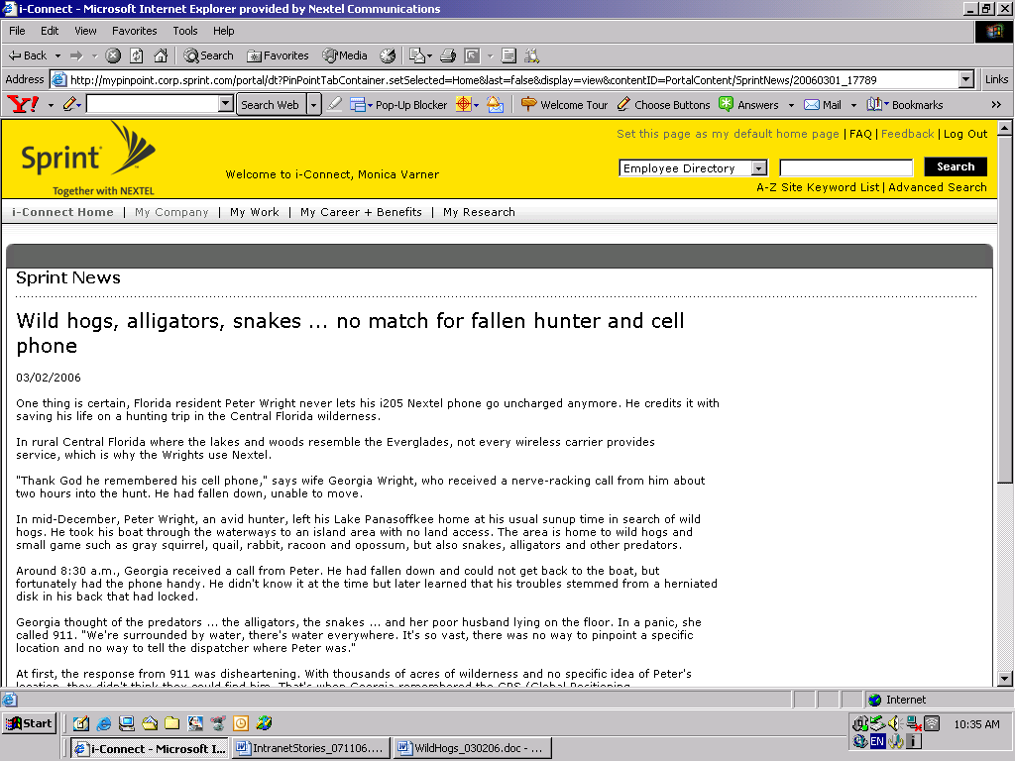

Article #3- Prized Purse

Prized purse: lost and found thanks to Sprint GPS services
(December 15, 2005) The silver purse in the median of US-52, about 5 miles South of Lafayette, Ind., was a glorious sight for Purdue University sophomore Jessica Ellis. She had miraculously found it 6 hours later with the help of Sprint GPS Mobile Locator!

Ellis recently started riding a motorcycle to keep transportation costs down. Sunday, Nov. 13, she rode home from Purdue to store her motorcycle for the winter and somewhere along the way, her purse was blown out of her saddlebags.
When she finished the 70-mile trek home, she was heartbroken to discover her purse missing … along with $200 in hard-earned cash, makeup and other irreplaceable items like her school ID, drivers license, and a brand new Nextel i850.
So her dad, Alan Ellis, engineer-Enterprise Data Solutions, stepped in to help. First, they drove up and down the route she had taken. They found the motorcycle cover but no purse. Then, the senior Ellis got an idea.

In a pinch, he relied on the knowledge of mobile data applications he shares on the job with accounts like Whirlpool, Steelcase, Herman Miller and Kellogg's.
He jumped onto www.nextel.com and activated "GPS Mobile Locator" for Jessica's phone. Because she worked late and had not charged her phone the night before, they kept their fingers crossed that the battery would last long enough for GPS Mobile Locator to activate and find her phone. For about an hour, the computer was not able to locate the i850.
"We finally gave up and had dinner. But right after dinner, it showed up. Zooming in on the image from our home computer, we could see her phone right there in the median and were able to place it within a few hundred yards," says Ellis.
They quickly drove back to Purdue that night. And, thanks to the GPS images they saw of her phone in the median, they had an excellent sense of where to look on US-52, a country highway. Mobile Locator pinpointed the phone within two cross-streets only 3/10 of a mile apart.
"My purse was sitting on the side of the road waiting for me to pick it up. I was so relieved! I had a lot of stuff in there that I really needed including my cell phone and license, and I was doubtful I'd ever see any of it again," says Ellis. "You have no idea how thrilled I was to see it ... I was the happiest person in the world."
Find out more about GPS Mobile Locator.
(screen shot on next page)
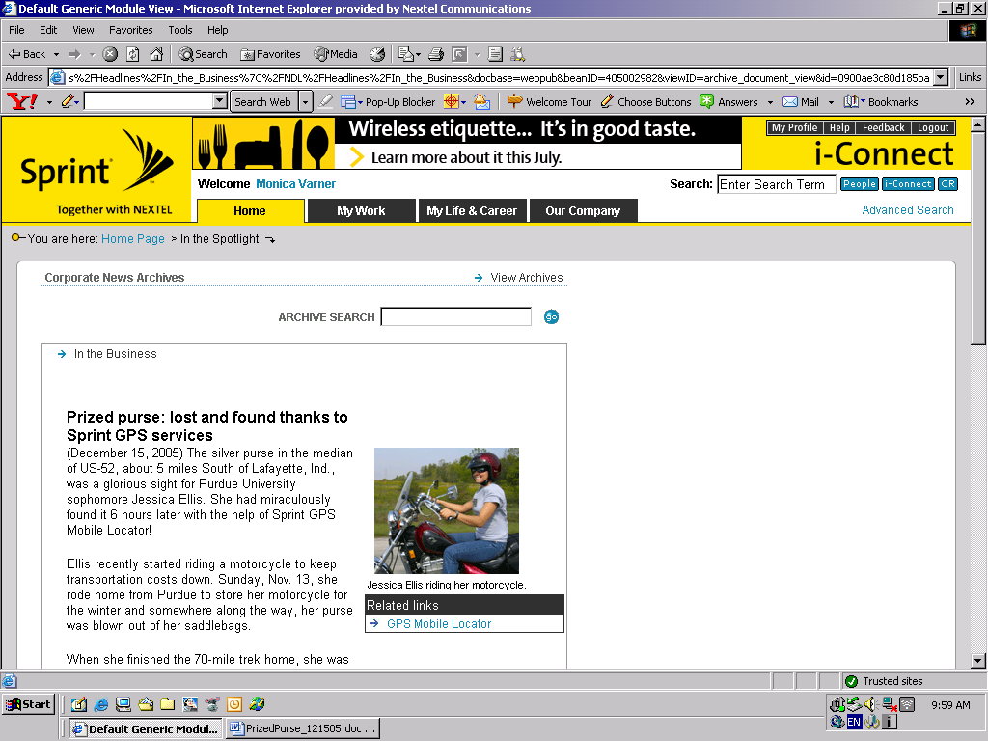

Article #4- Power Vision Marketing Campaign

Bringing Power Vision to the people

(Feb. 10, 2006) Did you ever stop to sample a mouth-watering dessert at a grocery store, and then purchase it? Think about it, it's that experience that gets you hooked on a new product. Well, along those same lines, Sprint is bringing our premiere Power Vision handsets directly to the people Jan. 9- March 26 with the innovative Sprint Power Vision (SM) Hookup Tour.
The tour will seed 3,000 Power Vision handsets (Samsung A920) amongst our target market (young adult, tech power-users in their 20s and 30s) and invite them to experience the amazing Power Vision Network - its speed, quality, ease of use and convenience.
"We designed this alternative program as a complement to our national TV advertising campaign. Our main goal is to enable our prospects to experience Power Vision for themselves directly with the handset, knowing that once they experience the speed of the network and the quality of live TV, videos and music, the product will sell itself," says Julie Goulding, manager-Acquisition Marketing.
The Power Vision Hookup campaign also will build a network of online and offline ambassadors across the nation to influence their social network to invest in Power Vision, based on their own positive experiences.
Coming to a city near you
The tour will bring the Power Vision experience to 20 cities through:
- Guerilla street teams -- Strategically positioning our teams near coffee houses, night clubs and entertainment areas, they are demoing services and giving away freebies.
- Mobile vehicles -- Two creatively wrapped SUVs and 14-foot trailers are hauling three lifestyle-oriented demonstration kiosks, depicting settings where consumers will use Power Vision services, including a coffee house, tailgate party and subway/train.
- Projection video -- High projection, video broadcast on sides of buildings are building Power Vision awareness and driving traffic to contest microsite.
- Online viral -- Viral video is driving traffic to contest microsite, as well as "Just the Facts" -- an online fact-based buzz created within targeted early adopter, tech-savvy communities.
- Ambassador program -- Through a high-tech online search tool, Sprint will select 600 qualified early adopters to serve as key influencers and provide them with a free phone and six months free service. The Power Vision message is being spread online through their online blogs, message boards, podcasts and in offline discussions.
- Power Vision Hookup contest* -- The tour is distributing 150 handsets in each city. The contest objective is to pass the handset on to as many people and ask them to register on the contest Web site, creating a Power Vision chain. Prizes are awarded to daily winners, members of the largest national "Power Vision Chain," and one national grand prize winner. In addition, Sprint will donate $5 for each pass, up to $25,000, to a charity in each local market voted on by local contestants.
The tour hit Boston and Phoenix in late January, and also includes Detroit, Miami, San Francisco, St. Louis, Los Angeles, San Diego, Seattle, Houston, Denver, Dallas, Atlanta, Austin, New York and New Jersey. Visit the tour Web site for specific dates.
About PowerVision phones
The Sprint Power Vision Network is based on state-of-the-art EV-DO (Evolution Data Optimized) CDMA technology. It gives our customers the combination of choice, speed and always-on availability to provide a seamless communication and ultimate entertainment experience, including:
- Full song downloads from the Sprint Music Store
- NFL network
- Live TV
- High-resolution imaging
*contest is not open to employees of Sprint Nextel, their immediate families or Sprint Nextel agents.

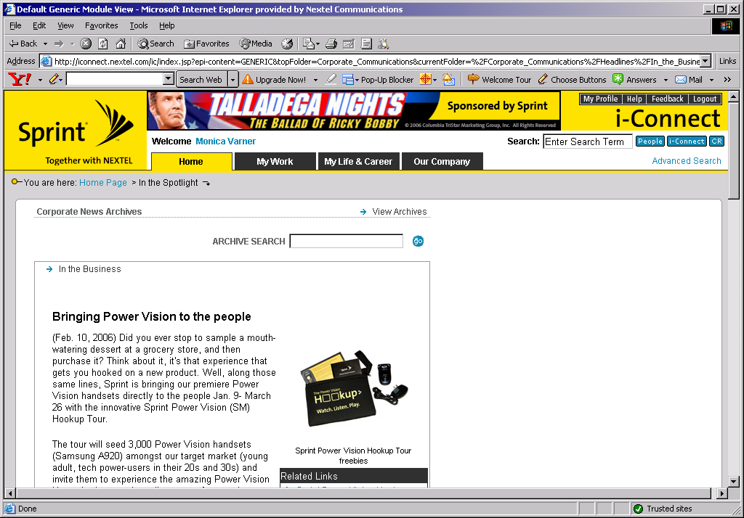

Article #5- GPS Jail

Sprint and GPS send bad-guy suspects to jail

(Jan. 6, 2006) The young man who entered her Southern California Sprint retail store looked shady to store manager Suzie Saenz, but she preferred to give him the benefit of the doubt. Unfortunately, her feelings of suspicion were confirmed not long after he entered when he cut the cable on a demo phone i-870 and fled her store. It was the Monday before Thanksgiving.
Moving quickly, Saenz jotted down the suspect's license number before he sped away; she called the police. She also called Brent W. Bailey, manager-Corporate Security and the pre-merger Nextel loss prevention manager responsible for fraud and theft in Southwest retail stores.
When filing the police report, they discovered the vehicle was stolen and the object of an ongoing police search. In fact, the police wanted the suspect and his partner, who sat in the car while the robbery took place, for other reasons. They both had criminal histories.
GPS to the rescue
That's when Bailey recommended they activate the GPS (Global Positioning System) feature on the stolen phone. As part of a plan to combat Sprint store burglaries in the Southwest, his security team had started activating some of the demo phones with GPS functionality in high-risk stores, with amazing results. "The GPS service has helped Sprint clear about 14 cases this year -- 10 burglaries, two armed robberies and even a narcotics case," Bailey says.
Bailey enlisted the aid of Amanda Rasmusen, representative-Data Accounts and Debra Winer, senior operations analyst, whom he had previously worked with on similar cases. They proceeded to activate a GPS feature to the stolen handset.
The police were thrilled to hear that GPS services might help them catch the suspects; they had been searching for them for weeks. In fact, they called Bailey regularly to find out if the feature had been activated.
On the Wednesday before the holiday, the activated GPS pinpointed the phone's location. Forty-five minutes later, the police arrived on the scene, retrieved the stolen handset and carted the two suspects off to jail.
"Courtesy of our GPS tools, teamwork and some good old-fashioned police work, these two guys enjoyed Thanksgiving Dinner in the Orange County Jail, where they currently reside pending trial." Bailey says.
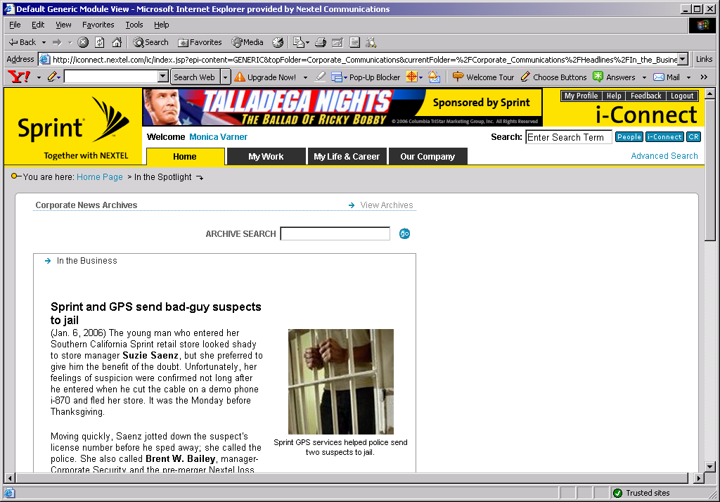

Article #6- Fashion Bags

Rock your fashion world with phone bags from Sprint

(Nov. 7, 2006) From an enchanting Hollywood vintage pouch to a glam gold-beaded bag, Sprint's got the fashion solution for your phone.
Both accessories are part of Sprint's new fall collection of cases from Nicole Miller. They debuted to Web and telesales on Oct. 3, and soon will be available at select stores.
"We were thrilled to introduce designs from a brand-name designer like Nicole Miller this year," Michelle Romano, senior marketing manager-Accessories, said. "Last year, Nextel released two very popular fashion lines -- one in the fall and one in the spring. Sales far exceeded expectations."

In response to customers providing feedback that they wanted to customize their phones, Sprint entered into an exclusive contract with Dooney & Bourke this past spring," Kim Glenn, manager-Accessories, said. "Four of the Dooney & Bourke cases on sale in Sprint Stores now were developed especially for Sprint."
Fashion favorites include:
Nicole Miller® Enchanting Hollywood Vintage Pouch -- Striped rust and hunter green sateen exterior, decorated with an antique jewel broche. Sage green, sateen lining interior. Magnetic flap closure to securely hold most small phones.
Nicole Miller® Mocha Vintage Suede Pouch -- Mocha suede exterior, sateen-lining interior. Magnetic flap closure to securely hold most small phones.
Dooney & Bourke® Black Heart Wristlet -- Striking, black leather pouch with captivating rainbow-colored hearts. Tan accents. Snap closure. Pocket in back. Doubles as "going-out" bag.
Dooney & Bourke® Pink Heart Pouch -- Pink background with blue and yellow heart design. Tan accents with wristlet included. Attaches to handbag. Snap closure.
Fashion meets function
In addition to adding some fun to your phone, the accessories are also functional.
Many can hold cash, ID and credit cards. And most feature an adjustable carry-strap that allows attachment to purses, briefcases, laptop bags -- or that can be used as its own carry solution. This is particularly appealing to women, who frequently don't wear belts and so can't use belt clips for their phones.
"I love my Iridescent Bronze Phone Purse with its over-the-shoulder strap," says Mona Reubens, admistrative assistant-Human Resources. "It makes me feel contemporary and hip. Plus, it blends well with evening wear and weekend wear, so I can use it outside of work, too."
The new Nicole Miller line is coming to limited Sprint Stores in November, just in time for the holidays. You can beat the holiday rush by previewing them on sprint.com.
Purchasing accessories
The employee discount is available as follows:
Pre-merger Nextel: In retail stores and through the i-Connect employee custom aisle. For more information: My Life & Career > Discount programs - internal discounts > Phone accessories.
Pre-merger Sprint: In retails stores, through telesales (1-888-431-3698) and the accessories hotline (1-800-974-2221). For more information: i-Connect>my career & benefits>employee discount>Sprint PCS benefits.
